Exercise Questions for Chapter 9: Multivariable Control
1. The complex theoretical model for a certain novel bioreactor has been linearized around, a proposed steady-state operating point resulting in the following approximate linear state-space model:
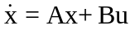
with
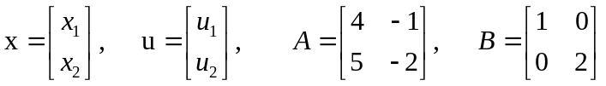
For simplicity we shall assume that the two state variables are measured directly so that:
- Show that the bioreactor is open-loop unstable at this operating condition.
- Obtain the corresponding transfer function matrix G(s) for the bioreactor at this operating point; find the system poles and zeros.
- Certain economic considerations dictate that the bioreactor is most profitably operated at this unstable steady state. Under proportional-only feedback control, using two single-loop controllers with gains 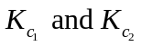with:
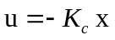
where
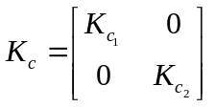
given that 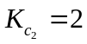, find the range of values which 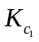 must take for the closed-loop system to be stable.
2. A two-input/two-output system whose transfer function matrix model is as shown below:
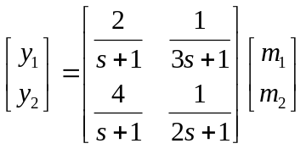
is under feedback control, using the y₁—m₁/y₂--m₂ pairing, so that the process transfer function matrix, G(s), is as indicated above; the controller, 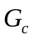 has been chosen as two pure proportional controllers, i.e.:
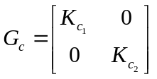
and it is desired to use the following specific controller parameters: =1, 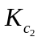 =5.
(a) Show that with the given controller parameters, the dosed-loop system will be unstable;
(b) Show that with the same controller parameters, if the loop pairing is switched (i.e., changing to a y₁ — m₂/y₂ — m₁ configuration) the system will be stable. [Hint Find the appropriate transfer function matrix first, since the transfer function matrix in this case is different from the one used in part (a).]
3. Derive an expression for the characteristic equation for the 1-2/2-1 configuration in Fig. Q3. Simplify and interpret this equation for the special situation where either Gp11 or Gp22 is zero.
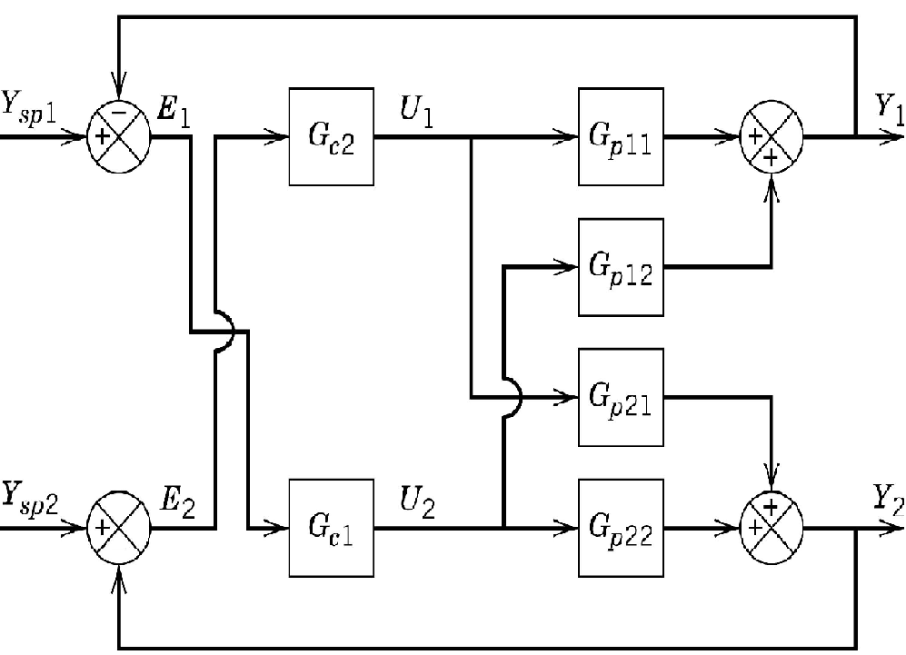
Figure Q3. 1-2, 2-1 controller pairing
- A combination of two drugs (hydrochlorothiazide and oxybutynin) is commonly used to regulate blood pressure in elderly patients. These two drugs mainly affect two physiological variables of the patient (blood pressure and urine production rate). Since the goal is to regulate both variables with these two drugs, interaction analysis has to be performed to design two SISO control loops. For the following model, there are two inputs and two outputs:
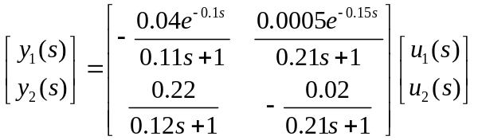

where
y₁ = normalized (dimensionless) blood pressure
y₂ = normalized urine production rate
u₁ = rate of hydrochlorothiazide ingestion
u₂ = rate of oxybutynin ingestion
- Calculate the relative gain array.
- What loop pairing would you suggest?
5. The transfer function matrix of a distillation process is given as
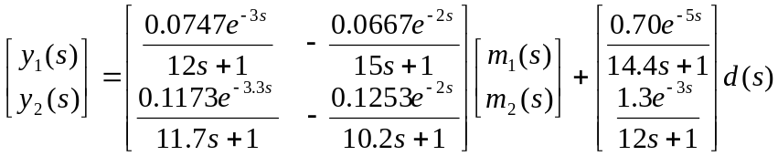
where y₁: distillate composition and y₂: bottoms composition are controlled variables, m₁: reflux flow rate and m₂: reboiler flow rate are manipulated variables, and d: feed composition is a disturbance.
a) Are the system outputs be able to maintain their set-points at steady state under disturbance?
b) Determine Relative Gain array (RGA) and Niederlinski Index (NI) to the process in (a).
c) If you are assigned to design a control system for this process, what kind of control structure you would like to adopt - centralized, decentralized or else, based on the parameters obtained in (b).
- A process to be controlled has two controlled variables Y₁ and Y₂, and three inputs that can be used as manipulated variables, U₁, U₂, and U₃. However, it is desired to use only two of these three manipulated variables in a conventional multiloop feedback control system. Transfer functions for the process are shown below. Which multiloop control configuration will result in the smallest amount of steady-state interaction between inputs and outputs? Justify your
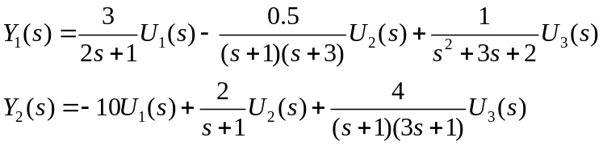
7. A process control engineer has decided to install an automated shower control system in a bathroom of her mansion. The design calls for a system that can deliver 3 gpm of water at 110F by mixing hot water at 170F, with colder water at 80F. Flow and temperature transmitters are available along with control valves for adjusting the hot and cold water flow rates.
- Calculate the required flow rates of hot and cold water, assuming that the density and heat capacity of water are constant.
- Calculate the relative gain array for the system and recommend a pairing of controlled and manipulated variables.

8. A process has the transfer function matrix
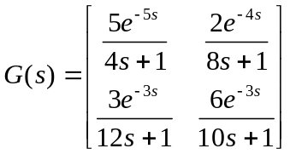
Find expressions for the simplified decouplers, discuss how they can be implanted based on practical considerations.

